|  |
| --- |
| Close-up image showing the leaf-sides of two oversized books side-by-side on a bookshelf, with additional books in soft focus background |
| Technical analysis of Edwards Lifesciences Corporation  Statistical methods and capital markets. |
| |  |  |  | | --- | --- | --- | | GAYRAT DADAMIRZAEV | 4/26/20 | QEA | |

***Description of company and main indicators (SP500 and EW).***

Edwards Lifesciences is American healthcare company, was founded in 1958 year after first invention of mitral valve. From that time to nowadays, the industry of the company remains production of medical technology(devices), such as artificial heart valves, transcatheter mitral valve, critical care technology and cardiac surgery technology. For 2020, number of employees exceeds 13 000 for total branches all over the world.

Main financial indicators.

Edward Lifesciences corporation, denoted as **EW** in stock market, is a component of S&P500. In S&P 500 component list, EW takes 121th place by its [weighted average market capitalization](https://www.investopedia.com/terms/w/wamc.asp). Rounded weight of EW is ≈ 0.2, while the minimum (NWS) is 0.004 and maximum 5.64 for Microsoft Corporation (MSFT). The [weighted average market capitalization](https://www.investopedia.com/terms/w/wamc.asp) of each individual component is then determined by dividing the market capitalization of the individual component by $21.4 trillion:

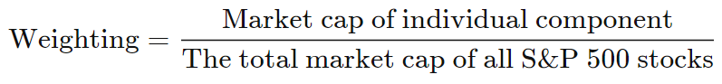

(*Source: Investopedia*).

According to yahoo finance, in 2019 company’s earnings accounted for 1.05 billion, this is the first time when the value exceeded 1 billion out of 4.35 billion of revenue, so the marginal profit is 24.08 % which is high enough.

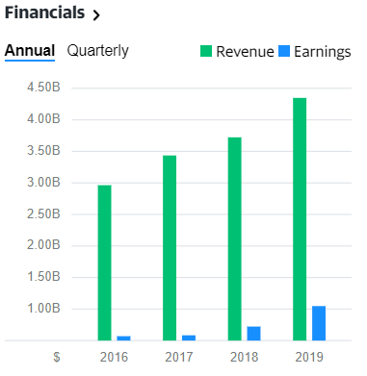

(*source:yahoo.finance)*

The graph shows linear increase, which indicates stability of growth.

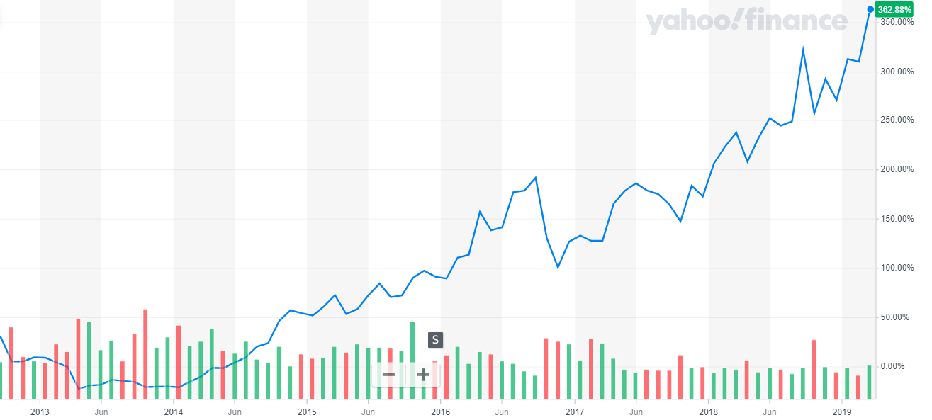

According to the graph over 8 years stock price trend is cycling in different ranges of the years.

Overall, from 2012 up today curves show increase in fund’s value up to 362.88%.

Here, Beta equals 0.81 considered as good indicator, that means the stock is 19% less volatile or less risky than market(S&P).

**β= Cov(Ri , Rmkt)/Var(Rmkt)**

where

Ri stock return, Rmkt market return

Beta=1 means, stock moves in line with market

Beta<1 less volatile than market

Beta>1 higher volatile than market

Beta is important coefficient, because it is used as a parameter of CAPM model for calculation cost of equity (asset rate of return).

Let’s take a look on P/E (Price to Earnings) ratio graph below.

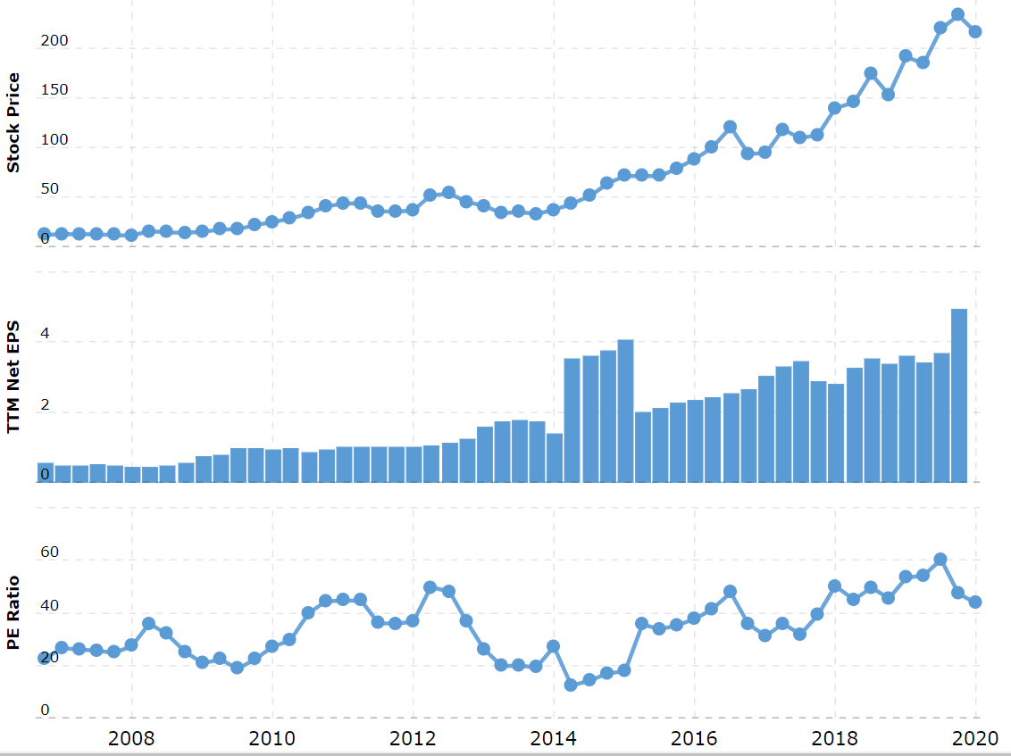

(*source: macrotrends.net*)

There is an increasing trend of Stock price as well as increasing histogram of net EPS. On the first sight it might be seem attractive **trading** **signal** for stock purchasing, because when the last price moves above the simple moving average (SMA) then it is **buying** signal (Tresl):

SMA8=207.206, Xt=216.02 => SMA8 < Xt for last 8 quarters (2 years).

However, it is important to know whether the price of stock is underestimated or overestimated with respect to the market. P/E ratio is 45.01, which tells that the stock price assumed to be overestimated, because the standard P/E ratio for USA is around 20 or 20 years.

But if we want to check whether our assumption of P/E is true or not, the EPS (earnings per share) growth is needed to calculate.

Let’s calculate compounded EPS growth over last five years by formula below, knowing that EPS for 31 Dec, 2019 is 4.94,

**Compounded EPS Growth = (EPS this period/EPS t periods ago)^(1/t) – 1**

* (4.94:2.01)1/5 -1≈**19.7**

**19.7** percent is compounded growth on earnings for 5 years. Comparing with 45.01 of P/E, EPS growth is almost 2.2 times less, means that the stock price of company is 2.2 times overestimated. For drawing more investors’ attention, company will need to increase its earnings up to 2.2 times.

Consequently, if the company will enough increase earnings regarding to stock price, then investors will be able to earn 100% profit of investment after 20 years.

But if earnings or return increase, then the risk rate of return should be similarly increase.

**Capital Asset Pricing Model or CAPM** is used to determine whether the expected gain worth it risk.

***R=Rf +* β*(RM-Rf)***

(CAPM formula)

where, R-rate of return in asset

Rf -risk free rate of return (0.62 %)

β – systematic risk (0.81)

RM -market return (10 %)

Respectively, R= 0.62 + 0.81(10-0.62) ≈ 8.22%

The 8.22% of expected return of security investor will **at least** expect in order to invest.

The CAPM model has only a single factor (market premium) with parameter beta. But what if there are some additional indicators that are influenced to determine the minimum expected return?

In 1992, Eugene Fama and Kenneth French realized that CAPM model can be developed by adding two more factors such as **size effect** and **book to market** that can be used in model to explain the expected stock return.

Since the fund market plays a tremendous role on the cost of company, investors and companies itself are interested in which factors can affect to the stock process. CAPM is theoretical model that includes only one factor, which is risk factor or risk premium. But for better studying or analyzing the return of stocks, model with one factor was not sufficient, because the values ​​of model such as fund expected return were performed suspiciously. The anomaly was detected by proof that the relatively small-size (market equity) companies exceeds the returns of big-size companies. Another disadvantage of CAPM is that it doesn’t count an effect of the ratio of book value to market. Then, in 1993, Fama and French introduced empirical three factors model, further in 2014 the model was adjusted to five factors model. The model aims to explain the change of stock’s return by combination of appropriate factors, such as risk premium, book-to-market and size factors. For five factor model there was included profitability and investment. The disadvantage of multifactor model is that today one can include many factors to the model by his own point of view. But anyway, the three-factor model is one of the most popular descriptive models of finance.

The goal of Fama French was to analyze (by their methodology applied on non-financial corporations) which factors are significant and which are redundant between five main factors: risk premium, book-to-market and size as well as leverage and P / E (Price earnings ratio).

By their research they conclude that, size, book-to-market and risk premium factors are significant in explaining expected returns. They concluded that beta alone did not explain the expected returns on stock and size and BE / ME (book to market ratio) factors absorbed the effects of leverage and E / P. Fama and French suggested that the stock risks were multidimensional. While ME represented one dimension of risk, BE / ME represented the other dimension of risk. Book-to-market ratio in their opinion could be the factor of relative distress. Firms with bad prospects estimated by the market tend to have higher expected returns than the good prospects.

Fama and French find out that book-to-market ratio is connected to the firms’ profitability. On average, firms, that have low BE / ME ratio, have higher earnings than the firms with high BE / ME ratio.

Fama and French summarize their paper by saying that the choice of factors is empirical and quite arbitrary. So, there remain open question on why these three factors are chosen to explain average stock returns and what are any other possible combinations of factors which improve the model.

**(*The cross-section of expected stock returns. Fama and French, 1992)***

Three factor Fama French formula:

***R=Rf +* β*(******RM-Rf) +* β*SMB +* β*HML***

Lets estimate parameters of Fama French model using regression OLS method in R software:

(daily data for ***RM-Rf, SMB and HML*** was extracted from Kenneth R. French Library data website:

<http://mba.tuck.dartmouth.edu/pages/faculty/ken.french/data_library.html#Research>)

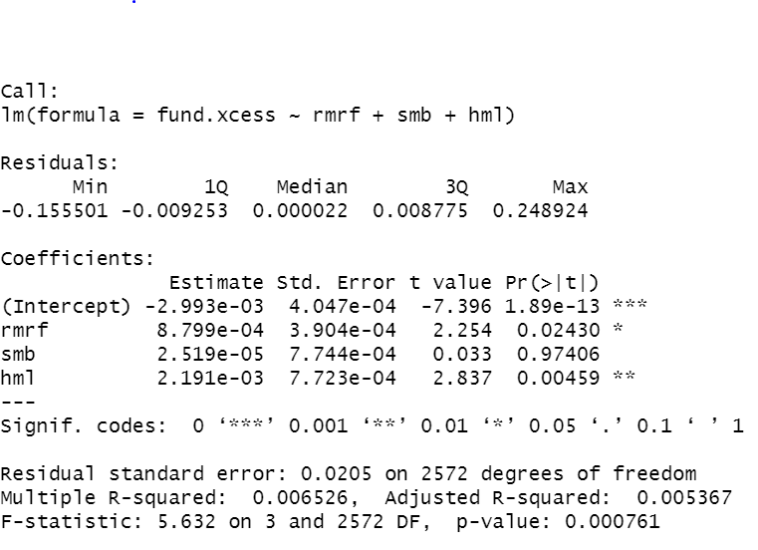

The table represents an output of Fama French regression model.

From the first sight we see that intercept(alpha) is negative value, which tells about possibility that earnings are very little for its risk. In order to check if it’s true, let’s check if the model is appropriate.

Firstly, we can notice that R2 is very low, the relationship explains only 6% of variation.

Secondly, coefficients of predictors are not all statistically significant, for example p value of smb is higher than 0.05.

And finally, the regression assumption about normality is not met. The residual QQ (quantile to quantile) plot is not normally distributed, as shown below:

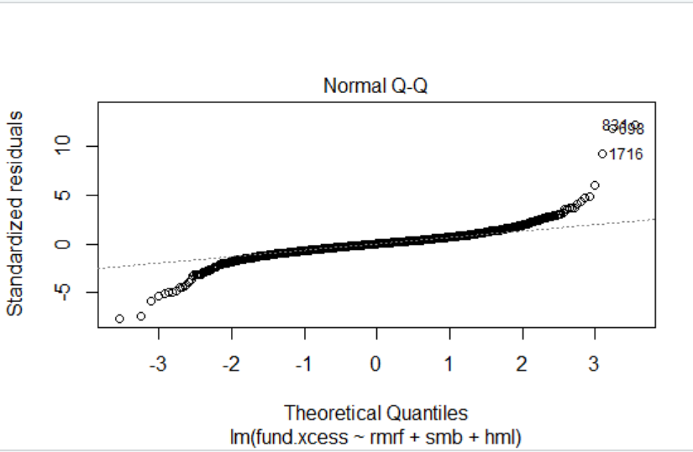

*(Fama French model residuals qq plot)*

There could be other violations in regression assumptions of model, however these three indicators mentioned above are enough to conclude to not proceed with this model and interpret its outcome.

***Leverage effect.***

When the stock price falls, volatility increases. Such relationship between stock returns and volatility, known as “leverage effect”

When the stock falls, then the leverage is strong, while the stock increases, then the positive stock returns reduce leverage. A fall in the market value of equity makes the firm more levered. Main question of the paper is how much of the "leverage effect" in stock returns and option implied volatilities can really be tied to leverage, and how much will need to be explained by other causes. There is existence of an asymmetric relationship between returns and volatility.

To determine the leverage behavior, in this paper authors made a theoretical and empirical analysis of relationship of equity volatility (implied and realized) and equity return of the levered firm, by comparing individual stocks and OEX index. During the analysis, authors faced with the discrepancies, for i.e. leverage effect should be the same for both implied and realized volatilities and should be constant when the market goes up or down. The logic of the theoretical argument suggests that the size of the leverage effect should not depend on whether the underlying stock return is positive or negative: a positive return should decrease leverage and volatility by about the same amount as a negative return of the same size increases. However, the practice shows a big asymmetry of effect, the individual stocks showed about same size of effect, but OEX shows 3-4 times larger than realized volatility.

Next approach, was to examine whether changes in leverage of actual amounts of outstanding debt and equity is associated with effect of the sample firms. Results showed that changes of bonds and stocks, didn’t produce a significant change of volatility.

For options, there was only a little difference between high and low strikes, but overall results were the same as above.

Finally, authors summarized that there is no leverage effect, there is effect of market down.

*(Is the 'Leverage Effect' a Leverage Effect?, Stephen* [*Figlewski*](https://papers.ssrn.com/sol3/cf_dev/AbsByAuth.cfm?per_id=17609)*,* [*Xiaozu Wang*](https://papers.ssrn.com/sol3/cf_dev/AbsByAuth.cfm?per_id=263663)*, 2000)*

***Leverage analysis and GJR GARCH model.***

Standard GARCH has one equation, it does not distinguish positive and negative errors. But the sign of the prediction matters, because variance bounce more after large negative expected return than after positive. Since market drops, leverage increases, the higher volatility (riskier).

To see leverage effect, we use two equations:

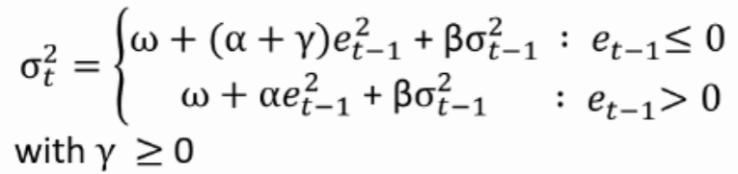

For estimating parameters, we will build gjr-garch model by using “rugarch” package in R (Alexios Ghalanos).

Output of parameter estimates is following:

* omega: 0.00003265
* alpha: 0.01083016
* beta: 0.84798787
* gamma: 0.10354777

0.00003265 + 0.11437793*e2t-1* + 0.84798787*σ2t-1*, for negative unexpected returns

0.00003265 + 0.01083016*e2t-1* + 0.84798787*σ2t-1*, for positive unexpected returns

Here we see how equations are different. The main coefficient in estimating leverage effect is gamma. If it differs than zero(positively), then there is asymmetry between positive and negative expected returns, which says that there is a leverage effect. Hence, the results are consistent with the conclusion of Figlewski and Wang(2001).

Quantitative analysis:

***Prices (EViews software)***

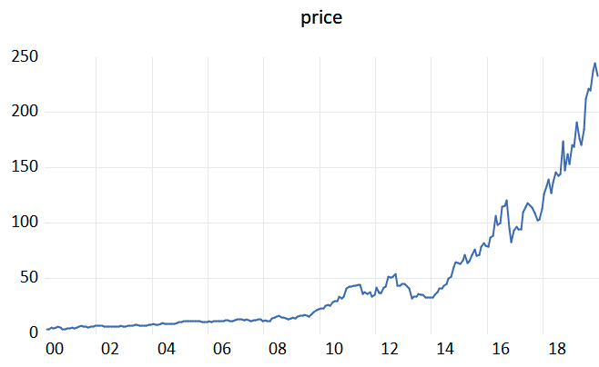

Graph represents exponential increase with fluctuations(cycles) and may be considered as stochastic trend.

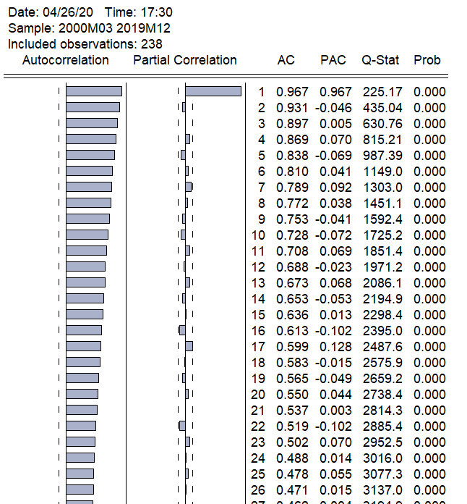

Correlogram above indicates high correlation over 0.96, that tells about non-stationary random process.

Partial autocorrelation has one lag, means that AR model with order 1 AR (1) may be used for estimating.

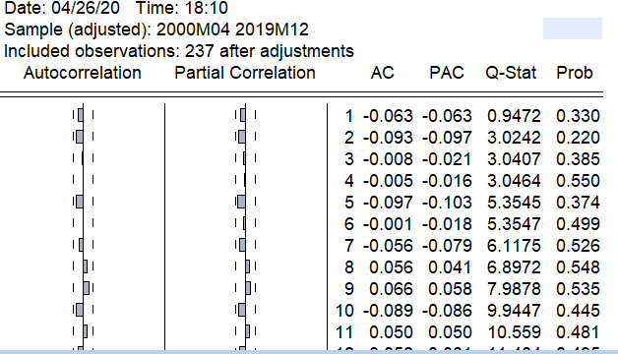

The residuals are white noise, since there is no autocorrelation. (residuals will not prevent to build fitting model)

Let’s check time series on stationarity by unit root test, pushed by Augmented Dickey Fuller test.

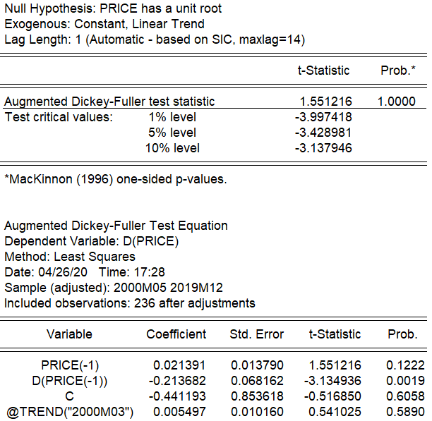

P values is 1, presence of unit root is not rejected, i.e. **presence of stochastic trend**

Absence of intercept is not rejected, i.e. **no presence of linear deterministic** **trend**, because intercept (C) is not statistically significant.

For forecasting we can add trend variables t for polynomial equation**:** *Tt* = **0 + **1*t* + **2*t*2 + **3*t*3 +**4*t*4.

Then we will get following:

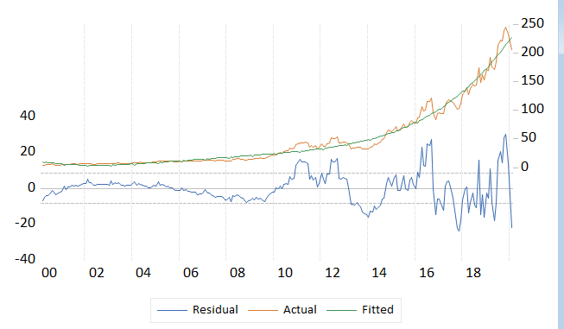

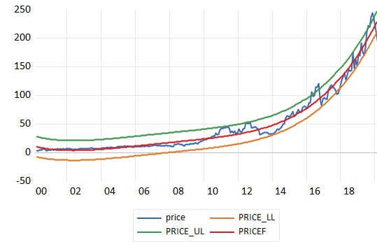

Confidence interval (price_ll(-2 s.e.) to price_ul(+2 s.e.)

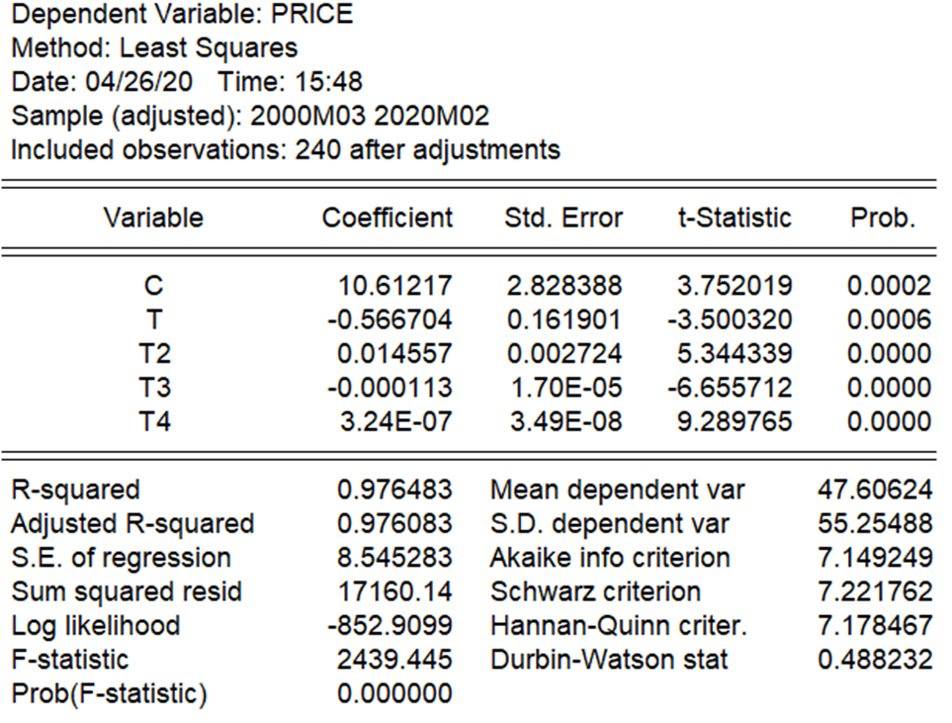

All variables are significant, R2 and Durbin Watson statistic are high enough, that implies a good quality of model which can be used for prediction. However, the time series cannot be modeled only by a deterministic trend, it is better to use exponential smoothing approach or ARIMA stochastic model, because there is autocorrelationshown below:

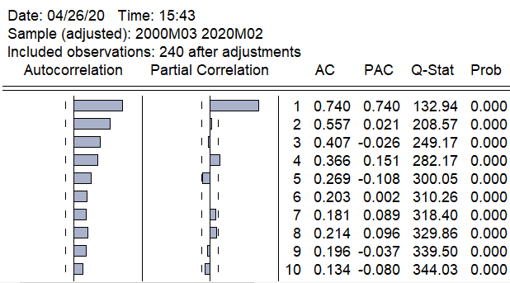

***Stock returns (R software).***

Using R studio let’s conduct ARIMA model for 1year daily stock returns (01/01/19- 01/01/20).

We will run function **auto.arima** from “forecast” package to automatically detect parameters, orders and best fitting model with higher accuracy of prediction .

For relative growth return, I’m going to use log returns:

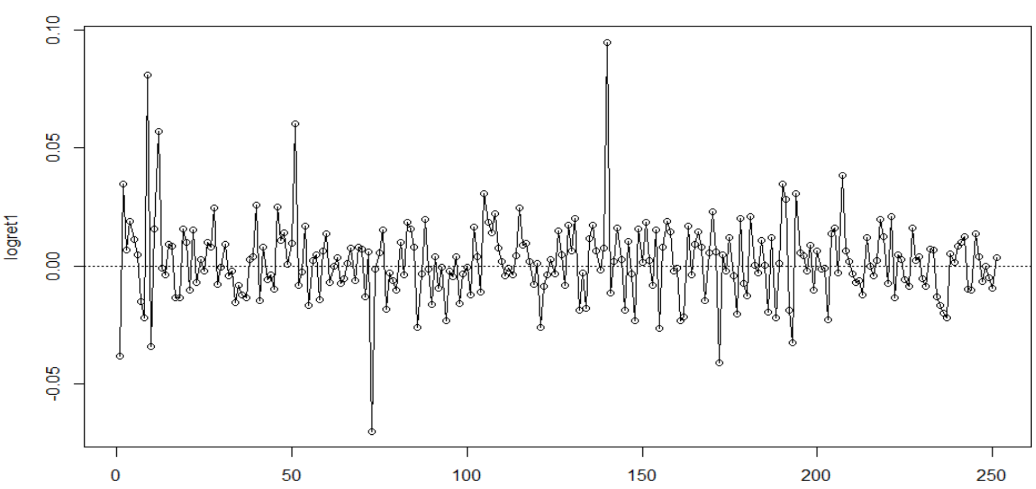

(Log returns of Edwards Lifesciences)

For building a necessary model, we need to set up augments of **auto.arima** function.

It is possible that the minimum AICc model will not be found due to these approximations, or because of the use of a stepwise procedure, therefore arguments **approximation** and **stepwise** will be assigned as FALSE. By setting allowdrift = TRUE, we allow that sample mean is not equal to zero. Since, the daily log return are stationary and not seasonal, the will be set up respectively. I set argument max.order=8, it gives the maximum of the sum of **p** and **q** which will be explored all possible combinations of ARIMA models that will not exceed 8 in sum.

Lets see what we’ve got:

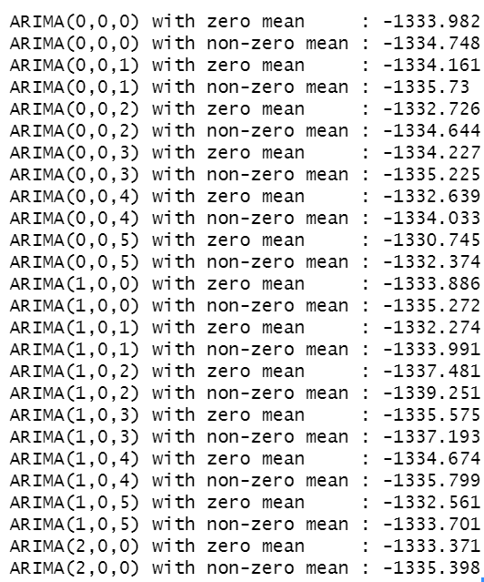

*(List of ARIMA models)*

This is a part of list possible ARIMA models. On the right sight are values of AIC(Akaike Information criteria). Software will choose that one, which has the lowest AIC.

Finally, model **ARIMA (1,0,2) with non-zero mean** was considered best.

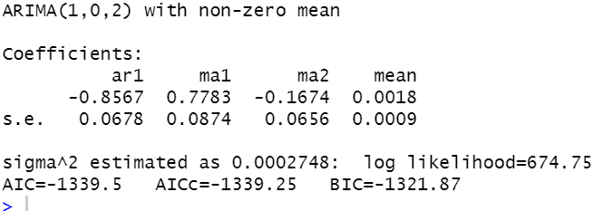

*(Output of ARIMA model)*

Now, it is important to check residuals.

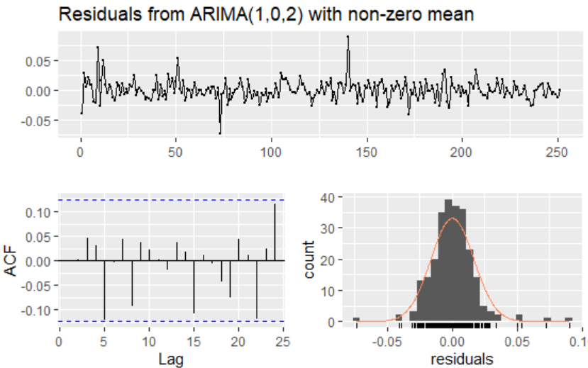

As we can see by ACF, lags are inside of tolerance limits, residuals have normal distribution and no autocorrelation.

Since residuals are considered as white noice, we may further proceed with model for forecasting.

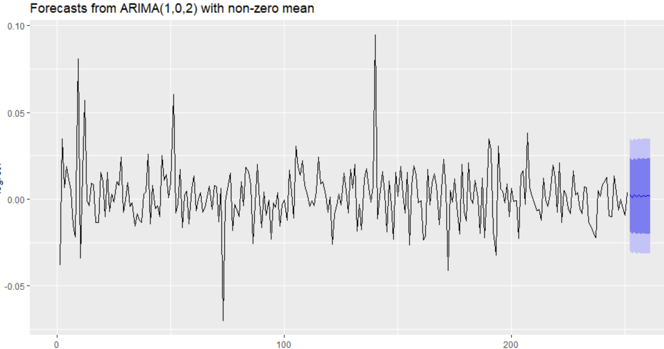

*(forecasting 10 days)*

Since the error metrics are very low, we may assume that model has high accuracy.

***R scripts.***

R script1 FAMA FRENCH:

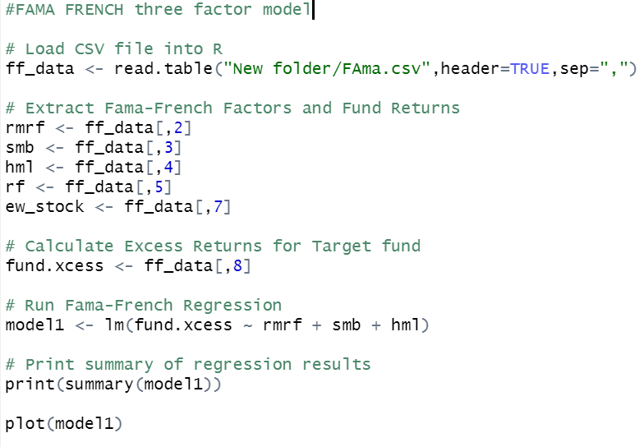

R script 2 GARCH:

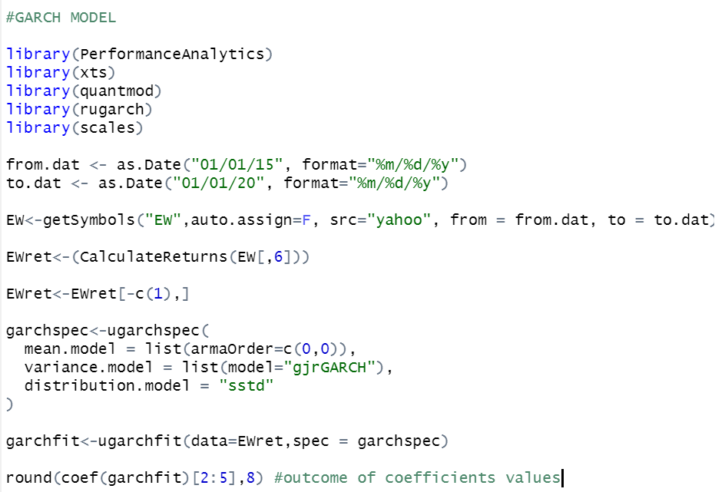

R script 3: ARIMA

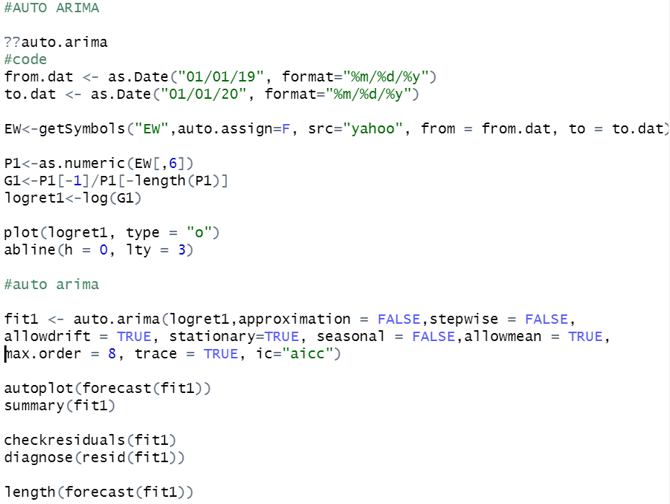

BIBLIOGRAPHY.

* *yahoo.finance ,2020*
* *Hyndman & Athanasopoulos, Forecasting: Principles and Practice, 2018*
* *Eugene Fama and Kenneth French, The Cross-Section of Expected Stock Returns, 1992*
* *Stephen* [*Figlewski*](https://papers.ssrn.com/sol3/cf_dev/AbsByAuth.cfm?per_id=17609)*,* [*Xiaozu Wang*](https://papers.ssrn.com/sol3/cf_dev/AbsByAuth.cfm?per_id=263663)*, Is the 'Leverage Effect' a Leverage Effect?, 2000*